**LEAF VEIN PROTOCOL (JAN 2018)**

**MATERIALS**

* Embedding cassettes: such as VWR Q Path Macrostar (if using compound leaves with very small pinnules, use cassettes with a smaller pore size, e.g. Q Path Microstar)
* Hot plate
* Microscope slides
* Coverslips (approx. 22x22 mm, although it may be helpful to have a larger size at hand)
* Sodium hydroxide, pellets
* Safranin-O (powder)
* Ethanol (pure)
* Toluene (pure)
* Pyrex dishes with lids
* Tweezers
* Dissecting microscope
* Brush and/or fine grain sandpaper

**SAMPLE** **PREPARATION**

Label a cassette with the sample code. Use pencil only –the solutions will erase any pen or marker writing.

Cut a 1x1 cm square from the middle part of the left side of the leaf. Avoid major veins and leaf edges. If the leaf is smaller, use the entire leaf. Place in a labelled cassette.

Samples bigger than 1x1 cm are harder to handle without breaking and may fold on themselves, as well as being more difficult to mount.

Some leaves have hairs or granules on their surface that can obscure the veins, making analysis difficult. If possible, remove these before the chemical processing to get better results and minimize the handling of digested samples. To do this, always work under a dissecting microscope. Use a cheap synthetic brush to gently brush away hairs. If needed, use a small piece of sandpaper (P600 or P800 grit) to sand the surface of the sample.

The samples should be flat and not too brittle. It is better to remove hairs from a small area of the whole leaf and cut the sample from that than to cut the sample and then remove the hairs, as cut samples are easily broken with excessive handling.

**CHEMICAL PROCESSING**

**Solutions**

1. Sodium hydroxide 5%: 50 g of sodium hydroxide (NaOH) in 1 L of deionized water (tap water may be fine if it is soft).
2. Water: 1 L of deionized water. Get fresh water every day and discard after use.
3. Bleach 2.5%: mix 250 mL of 10% sodium hypochlorite (NaClO) and 750 mL water (tap or deionized). Adjust quantities if using a different concentration.
4. Ethanol/water 50%: mix 500 mL of water (tap or deionized) and 500 mL of 100% ethanol.
5. Safranin 0.1%: 1 g of safranin in 1 L of 100% ethanol.

*Be very careful when handling safranin and cover all surfaces (balance, magnetic stirrer, lab bench, etc.); even diluted safranin has a high staining power and it is extremely difficult to clean. Recent stains can be removed with ethanol or soaking in bleach.*

1. Ethanol 100%: 1 L of 100% ethanol.
2. Ethanol/toluene 50%: mix 100 mL of 100% ethanol and 100 mL of 100% toluene.
3. Toluene 100%: 200 mL of 100% toluene.

The proportions don’t need to be exact, so it is acceptable to measure liquids in a beaker and to round up or down (within reason) when weighing solids.

Pour each solution (except for water, which should be renewed every time) into a different Pyrex dish of the appropriate size, cover with a lid and label the dish (not the lid) with the name, concentration and date of preparation of the solution.

**Protocol**

**1. Clearing**

1. 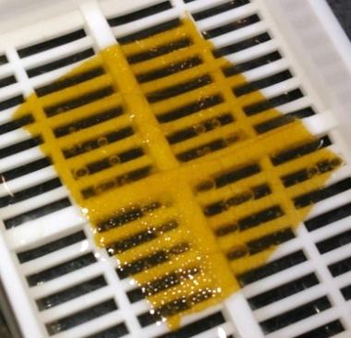Put up to 20 cassettes in a Pyrex dish with NaOH solution (1). Cover with the lid and leave on the hot plate at 60 °C (around setting #1 on the hot plate)*.* Most samples will be ready after 2-3 days. Thin or young leaves could take a few hours, while thicker ones can take longer than 3 days, so check daily one by one by opening the cassettes.  
     
   The samples are ready when are transparent, i.e., the cassette can be clearly seen through the sample (see photo). Cloudy looking samples are usually not yet ready, although very dense venation can also give samples a cloudy aspect. If available, use a dissecting microscope to help decide when they are ready: veins should be clearly visible. If undecided and the sample is in good condition (not starting to break up), leave it. There should be noticeable change from one day to the next. If not, the digestion is unlikely to progress any further.

*To open the cassettes, pick one with tweezers and hold it firmly with two fingers on the hinged side (always wear gloves), then pry it open using the tip of the tweezers. Wet cassettes often splash, so remember to wear the appropriate PPE.*

Digestion can be slowed down or sped up by changing the temperature. However, avoid too aggressive conditions (such as higher NaOH concentration or temperatures above 70 °C). Room temperature greatly slows down the reaction.

Long digestion times will result in the samples becoming mushy and breaking apart. As soon as that starts to happen, proceed with the sample as if it was ready.

The NaOH solution should be changed as it loses strength. Change it if the clearing does not appear to be progressing from one day to the next, or when the solution becomes dark or cloudy.

**2.Staining**

1. Use tweezers to transfer all the samples that are ready to the dish with water (2). Tilt the dish to wash the leaves.
2. Transfer the samples from the water to the bleach solution (3) and leave them for 5 minutes or longer (no more than 20 minutes). The samples are ready when they become whitish. Leaving the samples for too long in this solution can destroy them.
3. Transfer the samples from the bleach back to the water (2) to wash out the bleach.
4. Transfer the samples to the 50% ethanol/water solution (4). Leave for at least 1 minute and tilt the dish to ensure the samples are saturated with the solution. Keep the dish covered as the ethanol will evaporate quickly. Change the solution if the level drops*.*
5. Quickly transfer the samples to the safranin solution (5). Leave the samples for about 5 minutes and transfer to the dish with pure ethanol. Some samples may take longer to stain.

**3. Destaining**

1. Leave the samples to destain in the dish with pure ethanol (6) for 30-60 minutes. Longer periods are not harmful and can sometimes be beneficial. Use shorter times if some samples seem to lose colour too fast.
2. 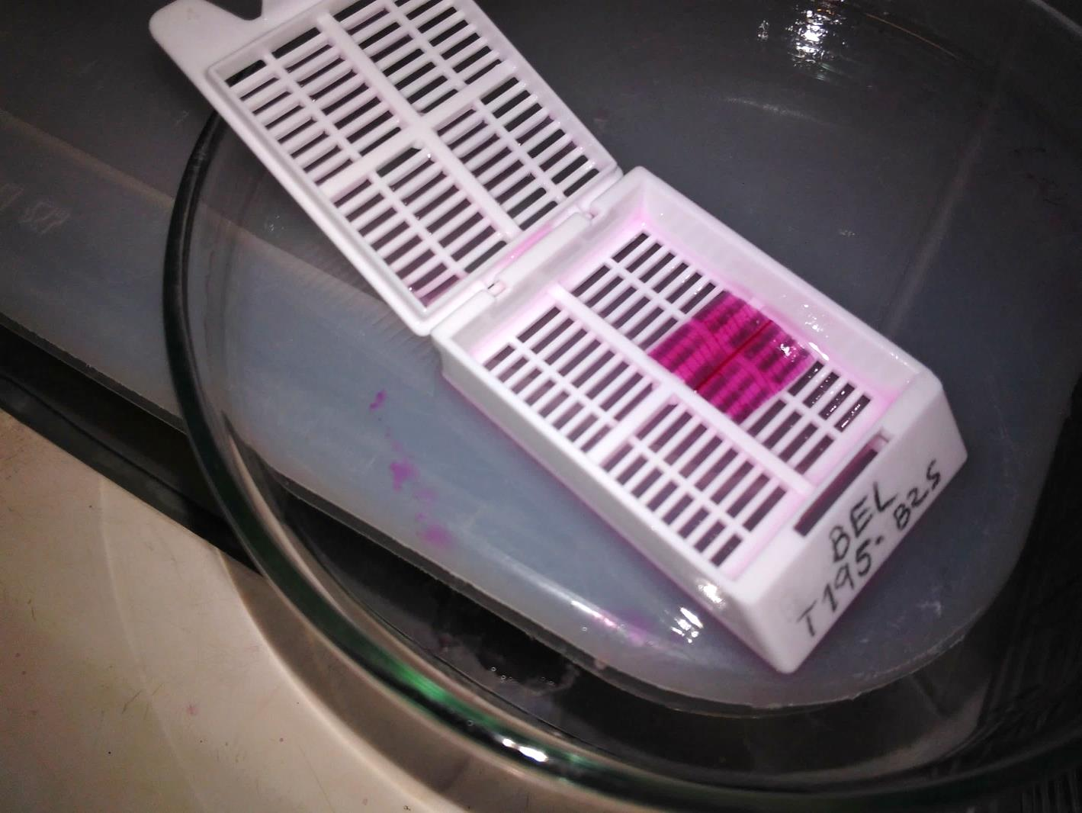After putting the samples in the pure ethanol, check that they stained homogeneously. Samples that are not stained enough can be re-stained.

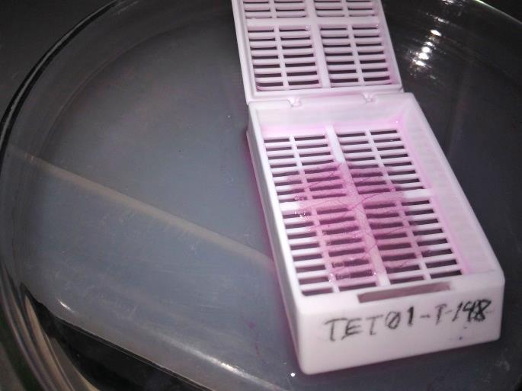Samples should be an intense red-pink colour right after putting them in ethanol, destaining to light pink over time (see photos), although the intensity will vary according to leaf thickness and vein density. Lighter spots indicate an incomplete staining.

When moving the samples,make sure that the ethanol does not fully evaporate from them*.*

1. While the samples are destaining, prepare the labelled glass slides and put them on a Pyrex dish lid or a similar surface covered with paper towels. Put the slides in the same order as the samples in the dish to prevent labelling mistakes. Slides can also be prepared beforehand if stored properly (i.e., not out in the open where they can collect dust).
2. Transfer the samples (up to 6 at a time if the container allows) to 50% ethanol/toluene solution (7) and leave them for 1-2 minutes, tilting the dish occasionally.
3. Quickly transfer the samples to the pure toluene solution (8) and leave for at least 1 minute (longer times are not harmful). Never allow the toluene to evaporate completely from the sample.

Change the toluene when it starts to stain the mounting medium (it will be dark pink/red) or earlier. Always change the toluene and the ethanol/toluene solution at the same time.

**4. Mounting**

Samples will harden a little in the toluene, but they can be hard to handle if they were already too thin or soft. If a sample cannot be picked up, leave the open cassette in the toluene and use the tweezers to lift up the floating sample from underneath.

1. Put some drops of mounting medium on the centre of the glass slide and spread with a coffee stirrer to the approximate size of a cover glass.
2. Pick up a cassette, open it and take the sample with the tweezers (this is sometimes not easy; if it takes too long, re-immerge the sample in the toluene to minimize toluene evaporation during mounting) and quickly put it on top of the mounting medium. (There’s approximately a 30 second window before the mounting medium starts to dry).
3. Quickly put a few drops of mounting medium onto the sample. Do not spread as it will introduce air bubbles. Thick samples will take more mounting medium to completely fill the space between the cover and the slide.

  ✓  ✗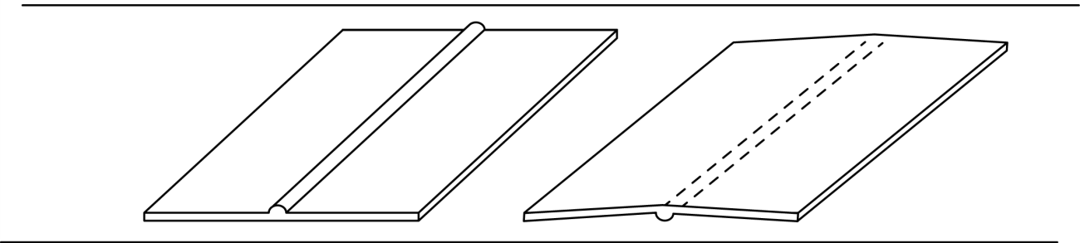

If the sample includes thick protruding veins that could not be avoided, lay it with the flatter side against the slide, as pictured (left). This will help with mounting and ensure that all of the sample can be in focus when imaged on the microscope.

1. Take a cover glass and hold it with the tweezers from one edge. Lower it until one edge touches the slide and move it towards the blob of mounting medium until it touches it. Gently let it fall on the sample, guiding the fall along the way with the tip of the tweezers. If done correctly, this will expel most possible air bubbles. (See figure)

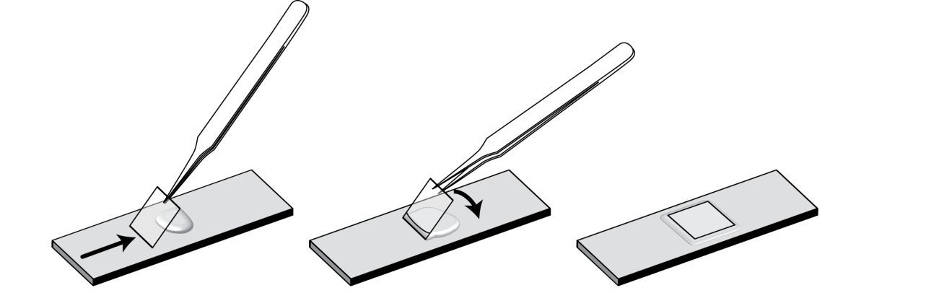

1. Gently press down the center of the cover glass to help spread the mounting medium, push air bubbles to the edge and make the sample flat against the slide. Be careful not to scratch the glass, use a coffee stirrer or a small weighted object. There should be enough mounting medium to take up the whole space of the cover glass with some excess around the edges.
2. Leave the samples to dry in the fume cupboard for at least two days before storing them in a box. Toluene will continue evaporating for a few more weeks, after which the sample might look better than when it was just mounted.

**Aftercare**

During the drying process, check the samples occasionally for growing bubbles. Large air bubbles that appear at the edge of the coverslip are caused by not using enough mounting medium for that particular sample, and they will grow as the mounting medium dries, ruining the sample. This can be sometimes avoided by applying more mounting medium on the edges.

Excess mounting medium that ends up over the cover glass can be carefully removed with a knife or razor after it dries completely.

**Removing the cuticle/epidermis**

Some species will fail to clear completely with the usual chemical treatment. If you decide to redo those, you can try to remove the epidermis so the veins can be seen more clearly. This is a very invasive and time-consuming procedure that can easily damage the sample and disrupt the venation pattern, in addition to being unnecessary in the vast majority of cases. Use it only with thicker samples that have repeatedly failed to clear and only when you are familiar with the species’ pattern. You will need:

* Dissecting microscope.
* Cheap, synthetic bristle brush.
* Fine point tweezers.
* Glass slide and water.

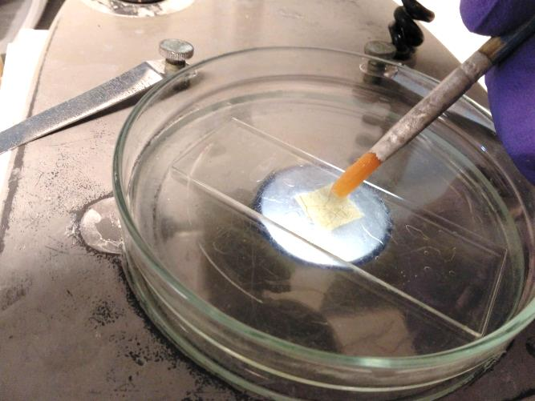After the samples have been slightly softened by the sodium hydroxide, carefully take the sample from the cassette and place it on a microscope slide using a brush or tweezers (put the slide on a Petri dish to protect the surface of the microscope). Under the microscope, brush the sample gently with short, slow strokes using a wet brush.

Try brushing on one small corner before applying the treatment to the whole sample. Use this to check for damage and to decide which side of the sample should be brushed (typically, one side has a more noticeable effect than the other).

If a flap of cuticle is lifted, you can use the tweezers to remove it, being careful not to damage any veins.

In some cases, it is better to softly tap on the sample with the brush, instead of stroking it. If the cuticle is soft enough, this can break it into small pieces that can be removed with the tweezers or washed away with water, leaving the intact veins behind.

Always work under the dissecting microscope, and never use the brush on a portion of the sample out of the field of view to avoid inadvertently damaging the sample.

**APPENDIX**

1. Incomplete digestion: the sample on the left is see-through but looks cloudy, and the colour is not homogeneous (1-2 extra days needed).

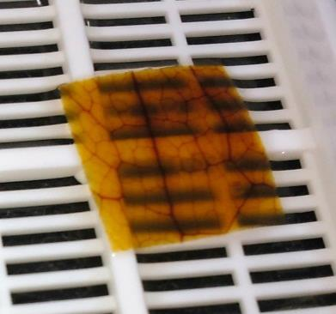

1. Depending on the species, it is not possible to completely clear some samples with this protocol. Fibrous species are especially likely to fail, as fibers will stain at least as intensely as veins.

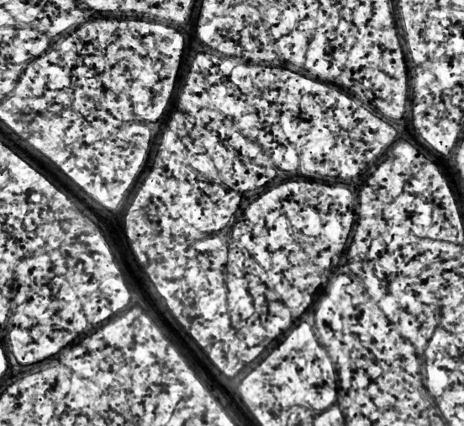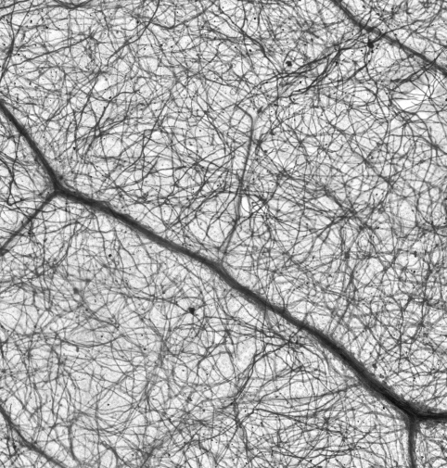

1. Air infiltration damage:

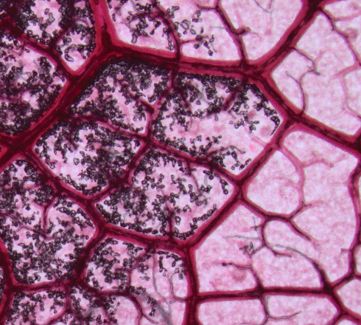

**Imaging**

Photos of the samples can be taken on a microscope with a 2X or 4X objective and attached digital camera.

Save the images in a lossless format (PNG, TIF or high-quality lossless JPG).

To have the whole sample imaged, take overlapping pictures as you move the microscope stage (about 20% overlap). Overlapping images can be stitched together using Image Composite Editor by Microsoft (free download: <https://www.microsoft.com/en-us/research/product/computational-photography-applications/image-composite-editor/>). After making a composite image, check that the stitching is correct.

An Olympus BX43 with a PLAPON Apochromat 2X objective and Olympus SC100 digital camera was used. Overlapping photos covering the whole of the sample were taken using Olympus cellSens Standard software, then stitched using Microsoft Image Composite Editor.